

**Table of Contents**

1. Problem Definition 3

i. Introduction 3

ii. Implementation Environment 3

1.1 User Stories 4

Customer  4

2. Flowchart

Purchase Products 6

3. UI\UX 7

3.1 Home page 7-8

3.2 About us 9

3.3 Furniture 10

3.4 Product 11

3.5 Contact us 12

3.6 Order 13

4. Summary 14

# **Problem Definition**

### Introduction

“Smartstore” is a company selling wardrobe and other home storage products specially space savers. They sell variety of products suiting every requirement and various sizes and qualities.

The website is to be developed for the Windows Platform using HTML5, JavaScript and Geolocation. The site should work well in all leading browsers including Chrome, IE, Firefox etc.

The Web site is to be created based on the following requirements.

1. The Home Page should be created making use of Sections with a suitable logo, the header section can be added which will show images of various storage solution product images.
2. The site must contain the links to navigate through any category for the information.
3. The site should display a menu which will contain the options for brief introduction about the various products available, location of the shop and any other information if required.
4. The information should be categorized according to the brand names of the products like if a User wants to see only “star” products or any other company products then he/she can click on a Link/button/menu etc and can see only that Brand products.
5. When a user selects any particular brand, a list of products for that brand will be displayed
6. A brief summary of features of the products should be displayed on the Web Page along with the picture but detailed Features should be stored in Individual Word documents which can be downloaded or viewed by the User who wishes to see the same.
7. The user should also be able to compare the various products of different as well as similar brands.
8. There should be a “Contact Us” page which will have the Address of the Company which should be displayed using GeoLocation API (eg. GoogleMaps) and the email address which when clicked will invoke the local mail client from where they can send an email.

### Implementation Environment

* HTML5/ CSS/ JavaScript
* Boostrap / Boostrap Hover
* Amazing Slider
* GeoLocation API
* Local Storage

# 1.2 **User Stories**

Customer

1. Sign in/ Sign up
2. View Products
3. Purchasing
4. Order

# Flowchart

## *Purchase Products*

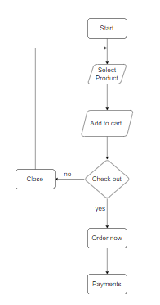

# **UI\UX**

## 3.1 Home page

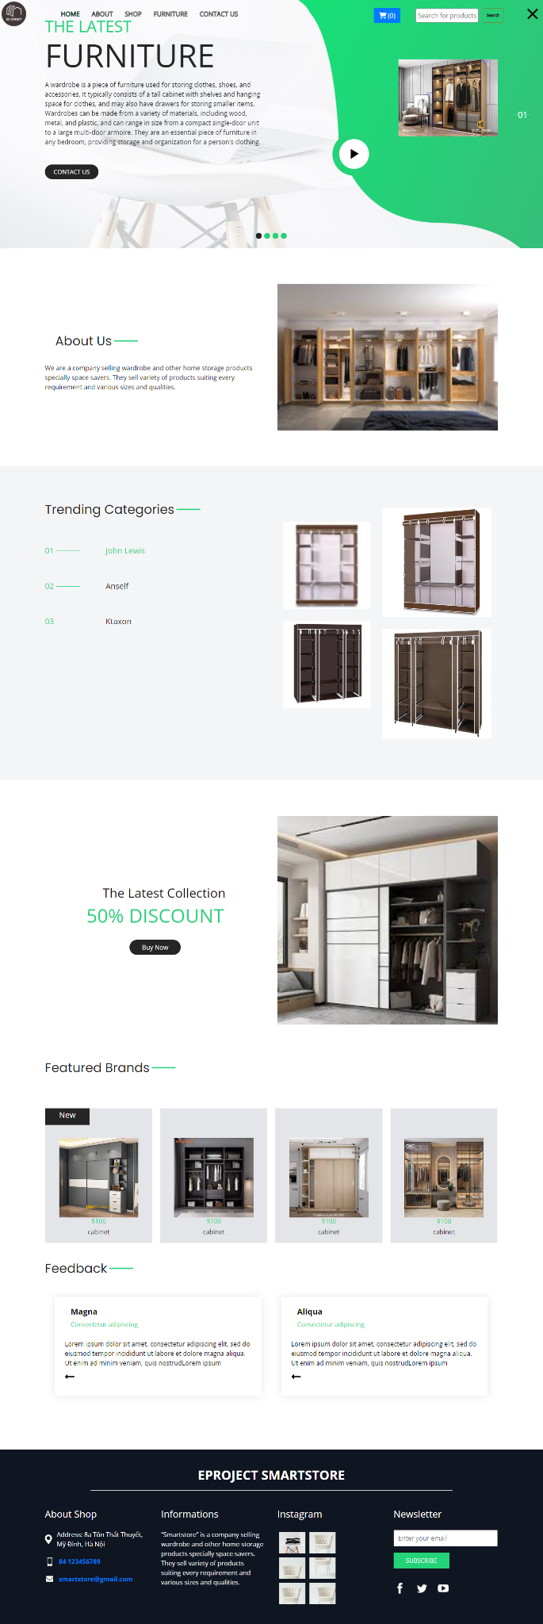

**3.2 About us**

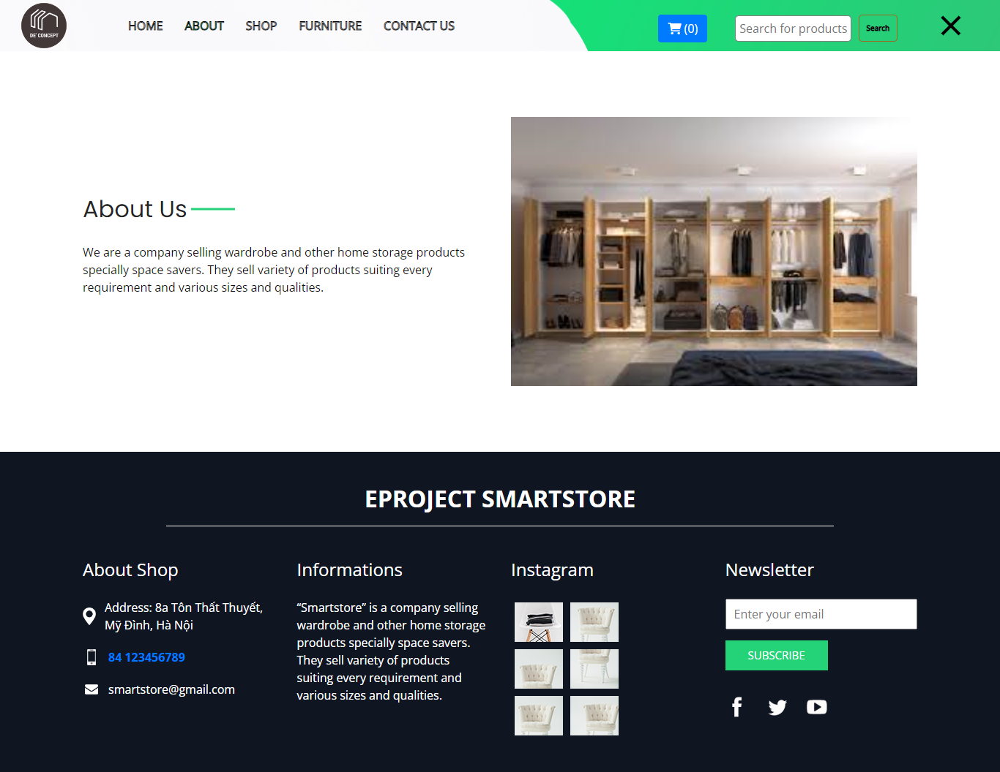

**3.3 Furniture**

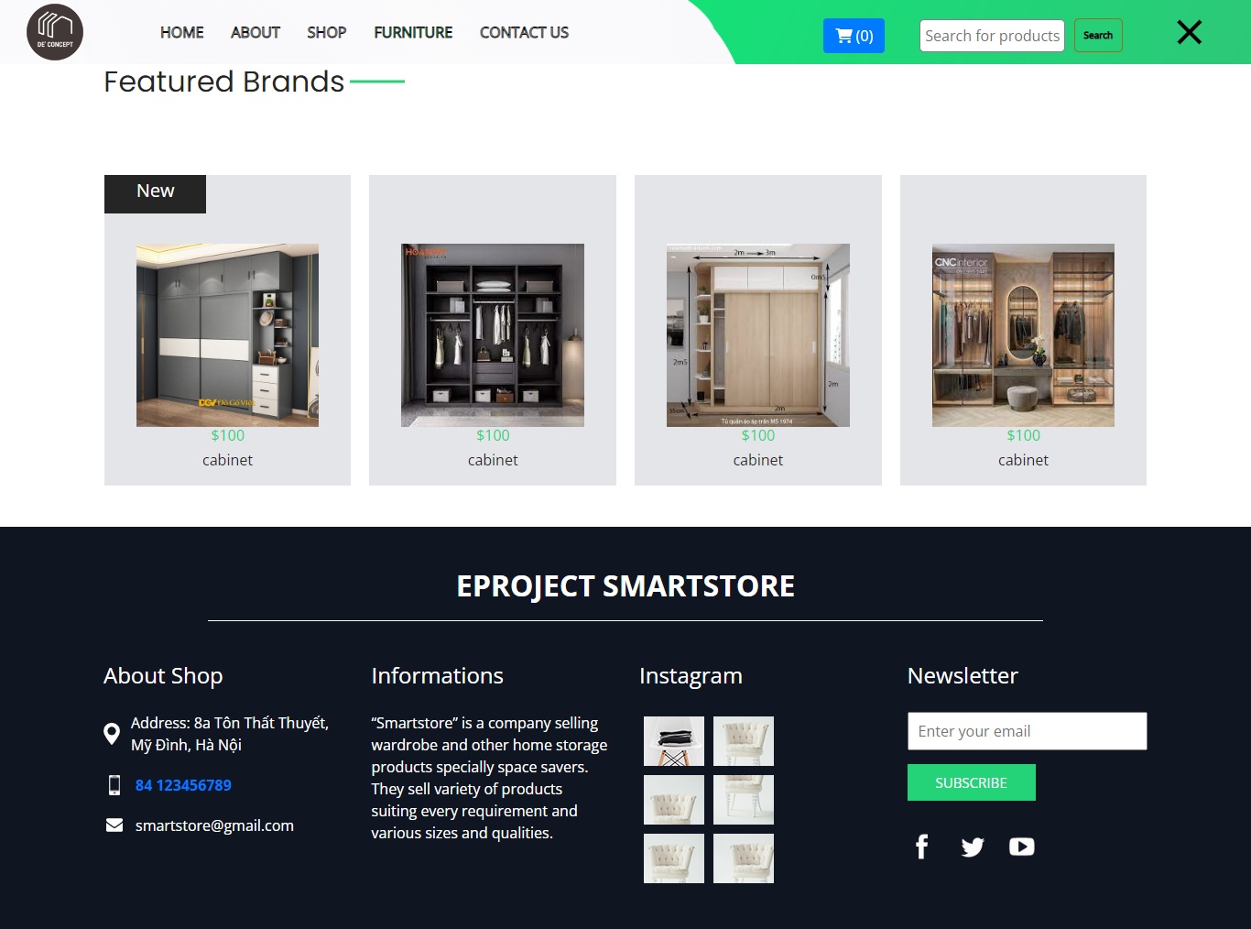

**3.4 Product**

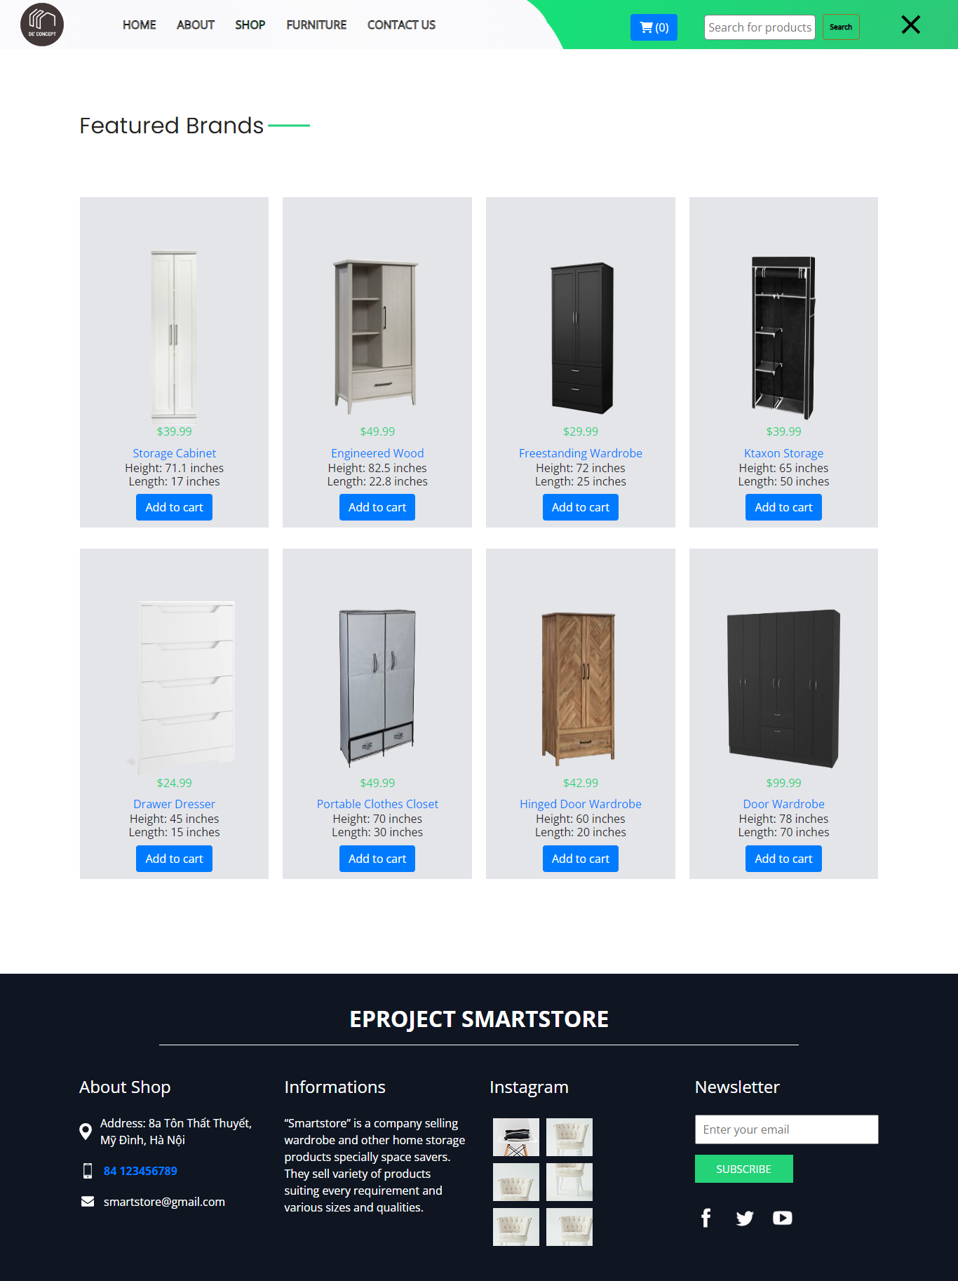

## 3.5 Contact us

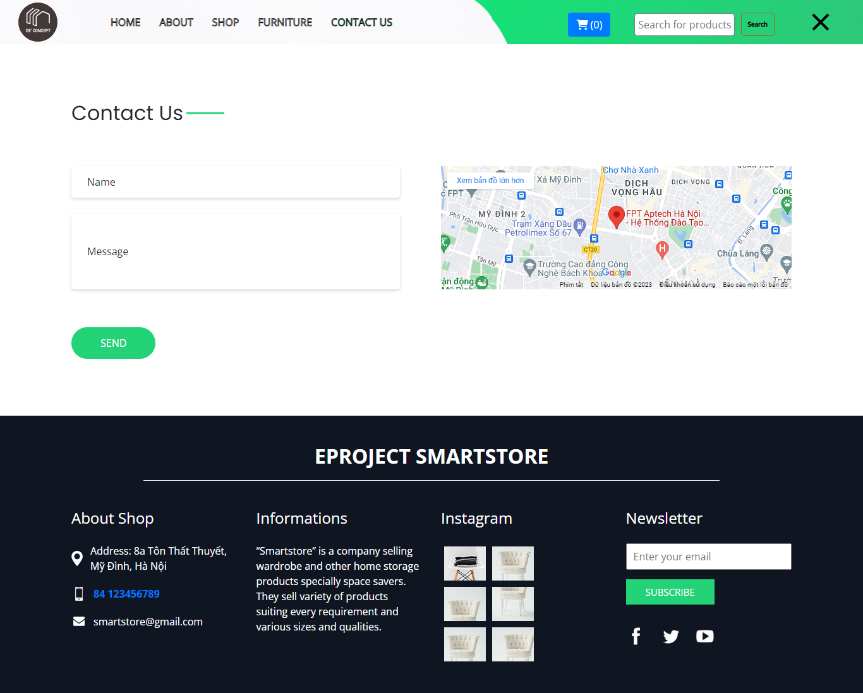

## 3.6 Order

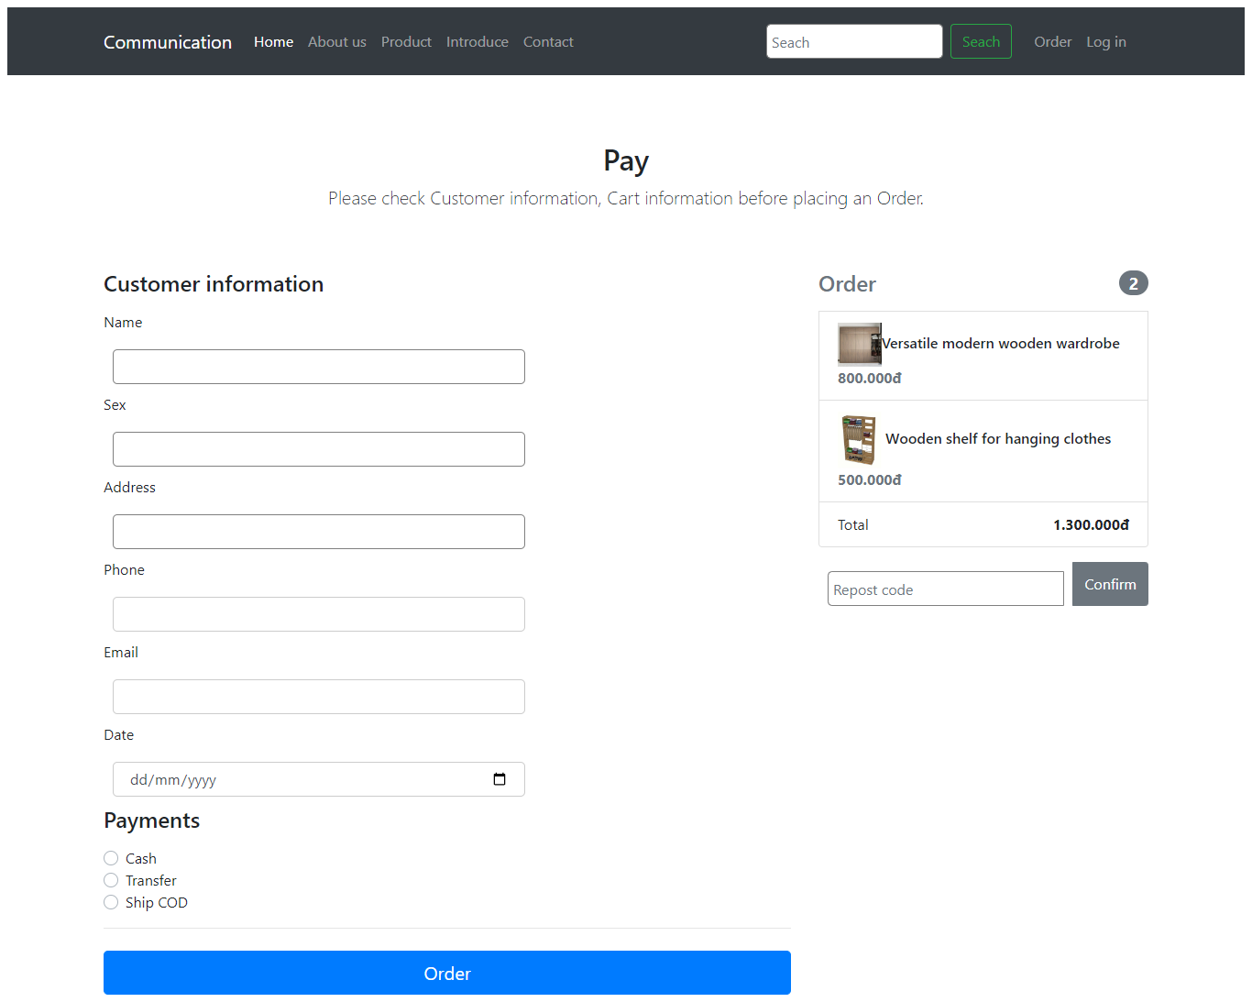

# **Summary**

Nguyen Thanh Loc: Home page

Do Viet Hoang: Product, Furniture

Trinh Ngoc Huy: About us

Le Van Tuan: Order

Chu Thi Yen: Contact us